10-04-2022

TESTING

Flask === for development of web page using python

**CLASS AGENDA:----**

1. Introduction to python selenium DOM
2. Use and access DOM elements
3. Class task

Right click on web page + inspect

There we can find the id /class/xpath for automation of webpage

**DOM SELECTORS**

Using DOM selectors we can automate

1. ID – will be like unique & always try using id only
2. Class – can vary and some times it vl be same
3. XPATH --
4. TAG NAME
5. CSS Selector

* With ID we can exactly match an an element on the page.
* If ID is not present try to use XPATH and then class

**USING ID METHOD:-**

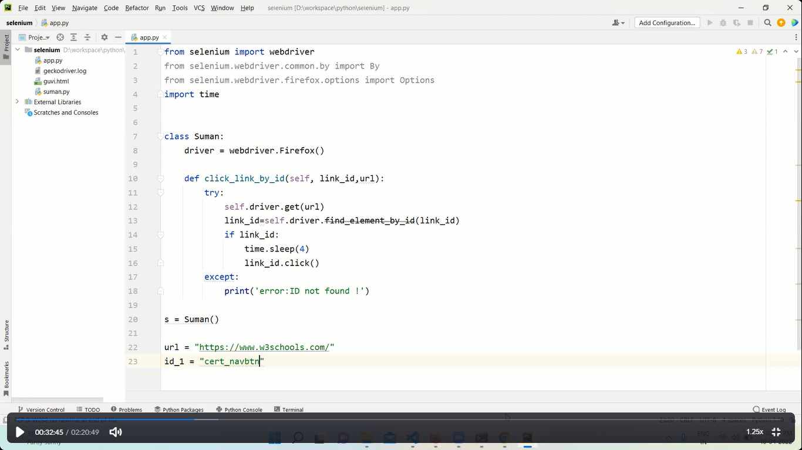

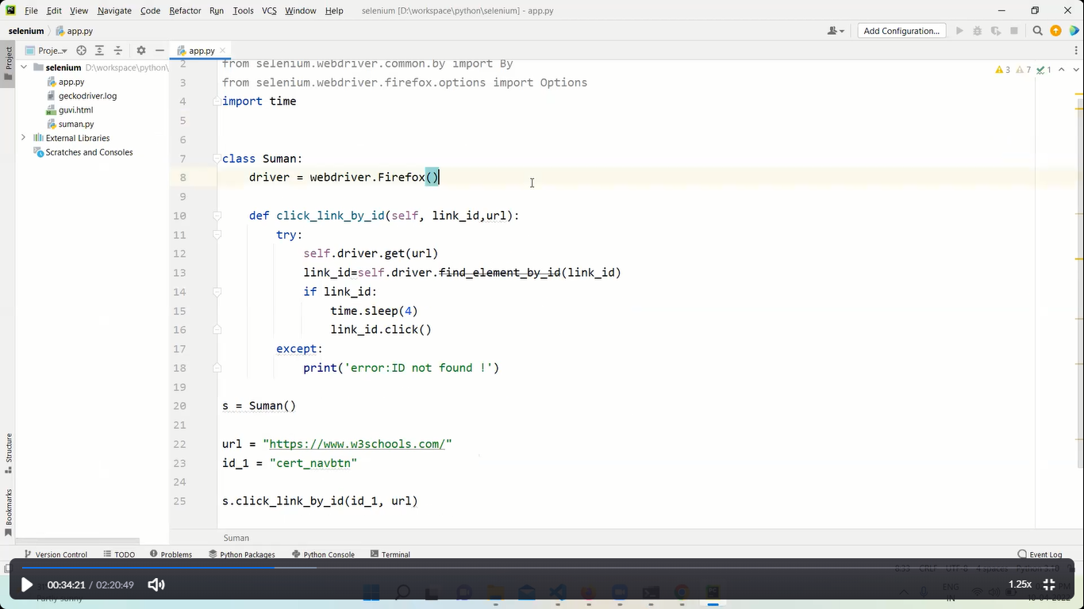

The above program is an example of DOM using ID

**USING CLASS METHOD :-**

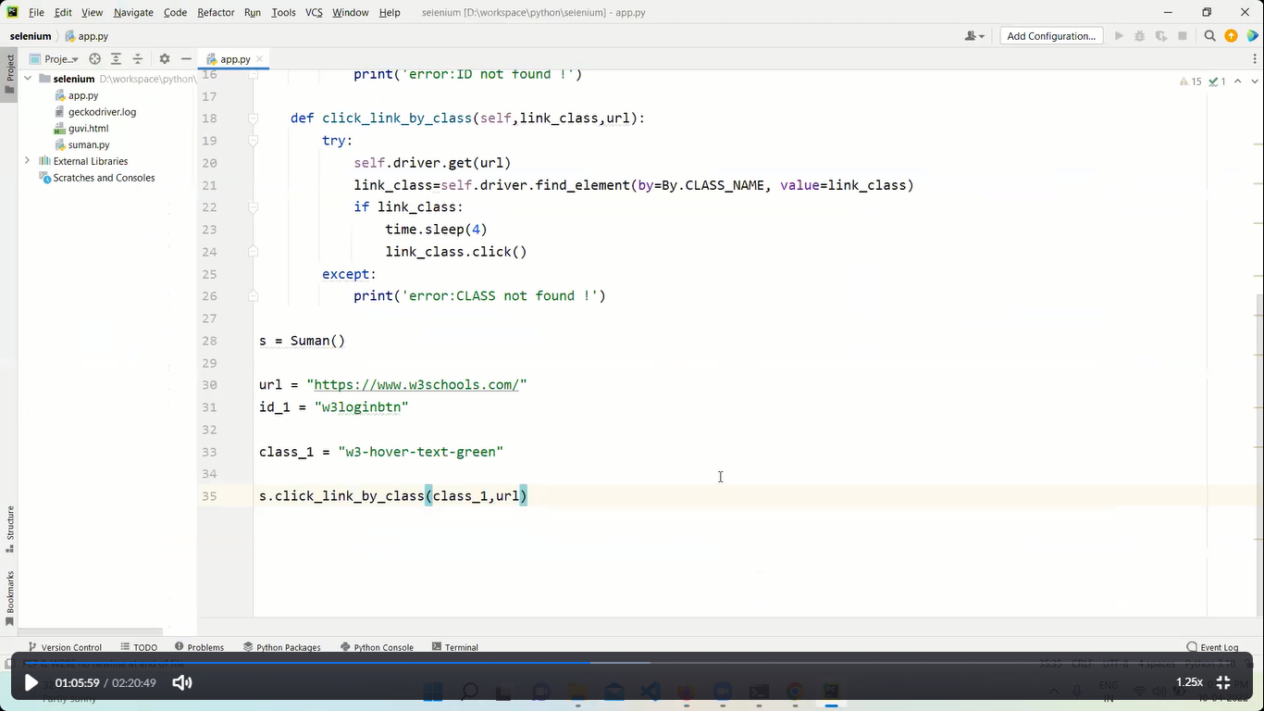

**USING XPATH METHOD :-**

XPATH is used to automate when there is no ID or CLASS to that particular item

To get the XPATH:-

This is exclusively for chrome browser

* Right click + inspect
* Click on that particular item and right click
* You get options copy xpath/copy full xpath
* Copy the path and paste in u r code
* Always go for full xpath

Here xpath – relative xpath

And full xapth – absolute xpath i.e full path & based on DOM

Disadvantage of XPATH : ---

* Suppose some one added a new element then the xpath will be changed

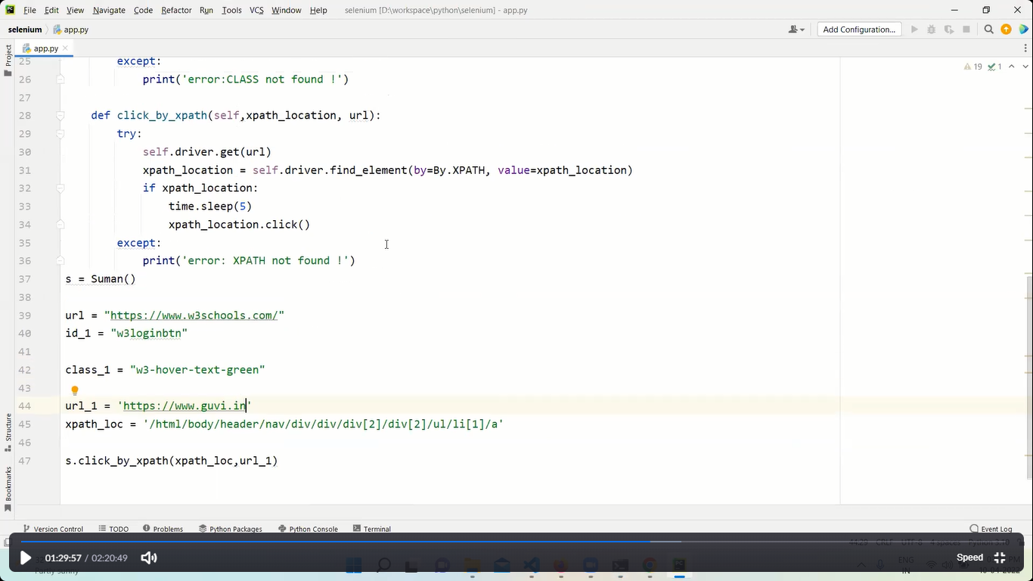

NOTE:-- Always go as per order

ID

XPATH – always check the xpath as it keeps on changing when the source code is updated

CLASS Task----------

* 1. Go to the amazon.in and create click methods based on ID's and CLASS ?
  2. Use the concept of ID, Class, XPATH on complex websites like Amazon, Reddit, Wikipedia, Guvi